Letter of Invitation

September 9, 2016

Dear Sir or Madam:

On behalf of Shanghai International Studies University, I feel greatly honored and pleased to extend our gracious invitation to Ade Kosasih (Gender: male; Nationality: Indonesian; Date of Birth: 1963-11-21; Passport number: A 5893865) to teach from 8 October 2016 to 8 January 2017.

We would like to invite him to share his professional knowledge and experience with our undergraduate students, which we believe will further enhance their understanding in related fields. And during his stay here, he will be accommodated in Hua Hongyuan (1666 Shuidian Rd., Shanghai 200083). Living allowance, accommodation and airfare during his stay here will be borne by our university.

If there is any question, please feel free to contact our office by email fao@shisu.edu.cn or by fax 0086-21-35373612.

Thank you.

Yours sincerely,
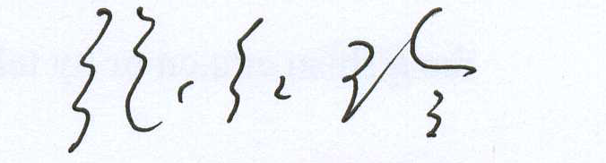

Prof. Zhang Hongling
Director of Office for International Cooperation and Exchange
Shanghai International Studies University

邀请函

尊敬的女士/先生：
我谨代表上海外国语大学真诚邀请Ade Kosasih（性别：男；国籍：印尼；出生日期：1963-11-21；护照号：A 5893865）于2016年10月8日至2017年1月8日来我校工作。
我们邀请Ade Kosasih教授来我校与学生们分享他的专业知识与经验。相信这必将会加强学生们在专业领域的认知。在华期间，他将入住华虹苑（上海市虹口区水电路1666弄）。在校生活费、机票费用和住宿将由我校承担。
请您协助Ade Kosasih办理签证有关事宜。若有任何问题，请您随时联系我处。联系邮箱：fao@shisu.edu.cn，电话：0086-21-35372616.

此致

敬礼！

张红玲教授
上海外国语大学
对外合作交流处处长
2016年9月9日

