Letter of Invitation

March 17, 2016
Dear Sir or Madam:

On behalf of Shanghai International Studies University, I feel greatly honored and pleased to extend our gracious invitation to Ms. Maria Blanca Gallego Fernandez (Gender: female; Nationality: Spanish; Date of Birth: 1990-05-12; Passport number: AAH817145; Occupation: Lecturer) from Universidad de Alcaláto visit our university from March 26 to April 10, 2016.

Ms. Maria Blanca Gallego Fernandez will do scientific research on marketing and explore more opportunities of cooperation between our two universities. We believe her visit will further develop the relations of friendship and cooperation. During her visit to our university, she will be accommodated in SISU Guest House (189 Xi Tiyuhui Road). All the expenses will be paid by her research funding.

If there is any question, please feel free to contact our office by email fao@shisu.edu.cn or by fax 0086-21-35373612.

Thank you.

Yours sincerely,
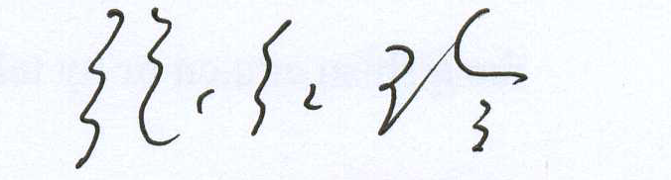

Prof. Zhang Hongling
Director of Office for International Corporationand Exchange
ShanghaiInternationalStudiesUniversity

邀请函

尊敬的女士/先生：
我谨代表上海外国语大学真诚邀请西班牙阿尔卡拉大学Maria Blanca Gallego Fernandez女士（性别：女；国籍：西班牙；出生日期：1990年5月12日；护照号：AAH817145；职业：讲师）于2016年3月26日至4月10日来我校交流访问。
Maria Blanca Gallego Fernandez女士将进行市场营销研究，并拓展两机构间合作的领域。我们相信，Maria Blanca Gallego Fernandez女士的来访将进一步加强两机构间的友谊和合作。在此期间，她将入住上外迎宾馆（西体育会路189号），其访华的一切费用将由其本人的科研经费承担。
请您协助Maria Blanca Gallego Fernandez女士办理签证有关事宜。若有任何问题，请您随时联系我处。联系邮箱：fao@shisu.edu.cn，电话：0086-21-35372616.

此致

敬礼！

张红玲教授
上海外国语大学
对外合作交流处处长
2016年3月17日

